**HIMALAYAN INSTITUTE OF TECHNOLOGY**

**DEHRADUN**

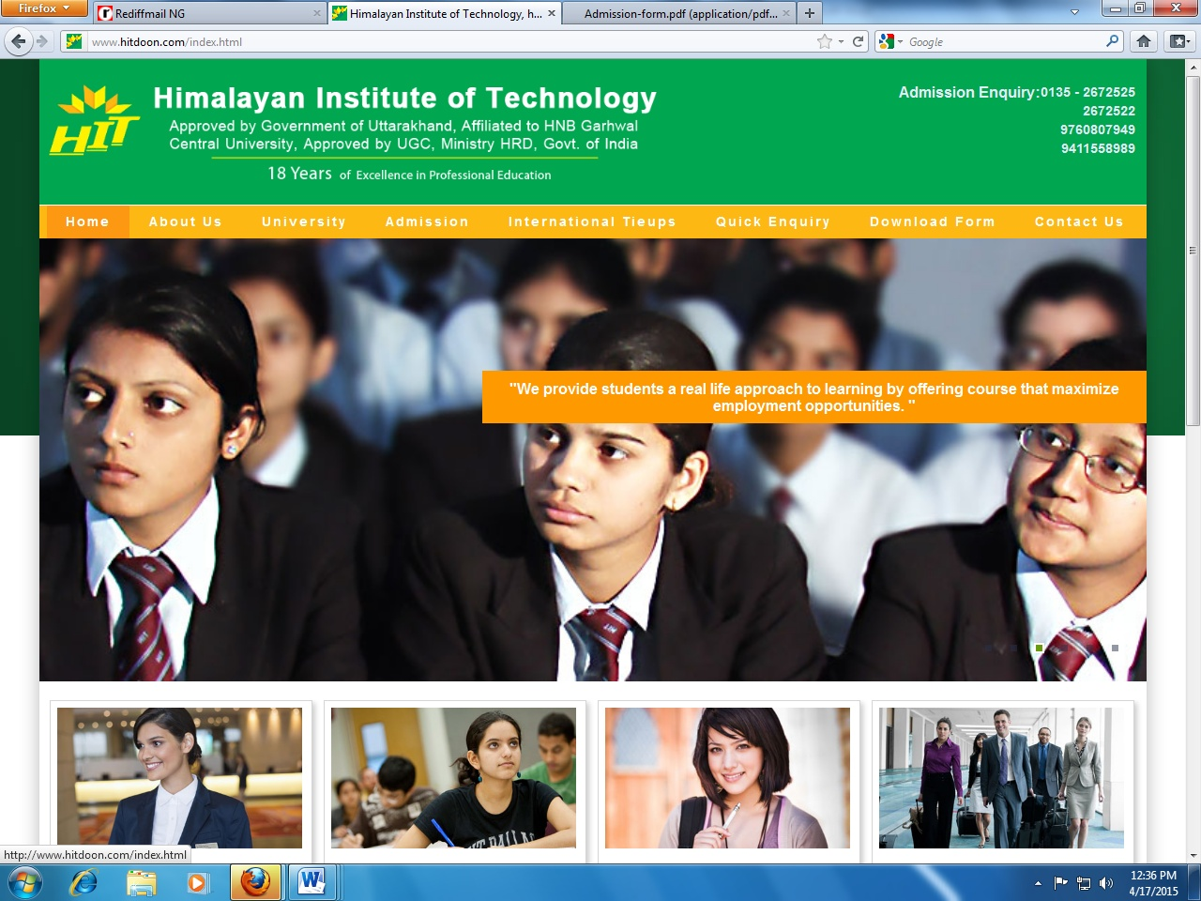

**PROJECT REPORT**

**ON**

**“Banking System”**

**AT**

**Excess Computer Education**

**DEHRADUN**

**SUBMITTED FOR PARTIAL FULFILLMENT OF**

**BACHELOR OF COMPUTER APPLICATION**

**H.N.B GARHWAL UNIVERSITY, SRINAGAR**

**2013-2016**



**SUBMITTED BY : SUBMITTED TO :**

**ASHISH CHAMOLI MR.YOGESH JUYAL**

**BCA6thSEM**

**ENROLLMENT NO:-G1326505**

HIMALAYAN INSTITUTE OF TECHNOLOGY

DEHRADUN

(AFFILIATED TO H.N.B. GARHWAL UNIVERSITY,SRINAGAR)

CERTIFICATE

This is to certify that project report entitled "Banking System" submitted by Mr. Ashich Chamoli partial fulfillment to the requirement for the award of the degree Bachelor of Computer Application is a record of bonafide work carried out in this organization under my supervision has not been submitted anywhere else for any other purpose.

Mr. Yogesh Juyal Mrs. Arrchana Jasola

(Subject In charge) (Principal)

Training Certificate

This is to certify that Mr Ashish Chamoli, S/o. Shri Chintamani Chamoli, student of B.C.A(Batch 2013-2016), Student of Himalayan Institute of Technology, Dehradun Uttarakhand has completed his training on Java.

The duration of training was from 1st Jun 2015 to 31st Aug 2015**,** under the supervision of Mr. Rajiv Bhatia, Designation Director of Excess Computer Education and Software Solutions.

During the training we found him quite sincere, hard working and his conduct & behavior was good.

Signature :__________________

Name :__________________

Designation :__________________

ACKNOWLEDGEMENT

I am grateful to my college **HIMALAYAN INSTITUTE OF TECHNOLOGY**, Dehradun and our principal **Mrs. Arrchana Jasola** for giving me an opportunity to undergo training program which is a part of Course curriculum in **BCA** [BACHELOR OF COMPUTER APPLICATION]. I have prepared a project entitled "**Banking System**".

I am also grateful to my faculty **Mr Yogesh Juyal** for guiding me and supervising to complete the project report.

**Ashish Chamoli**

**BCA 6th Sem**

DECLARATION

I hereby declare that project report entitle, “Banking System”, written and submitted by me, under guidance of computer Science faculty in my original work.

The finding in the report is based on the task done by myself in the Excess Computer Education and Software Solutions, while preparing the report, I have not copied anything from any source or other project submitted for similar purpose.

Place: Dehradun Ashish Chamoli

Date: BCA 6th SEM

ABSTRACT

Input Design is the process of converting a user-oriented description of the input into a computer-based system. This design is important to avoid errors in the data input process and show the correct direction to the management for getting correct information from the computerized system.

It is achieved by creating user-friendly screens for the data entry to handle large volume of data. The goal of designing input is to make data entry easier and to be free from errors. The data entry screen is designed in such a way that all the data manipulates can be performed. It also provides record viewing facilities.

When the data is entered it will check for its validity. Data can be entered with the help of screens. Appropriate messages are provided as when needed so that the user will not be in a maize of instant. Thus the objective of input design is to create an input layout that is easy to follow